Y3 Knowledge Organiser
History- Stone Age to Iron Age
Question: How did Britain change from the Stone Age to the Iron Age?
Concept:

Key Facts | History Skills
- It was a very long period of time.  - Split into three periods: Palaeolithic (The Old Stone Age - Prehistoric), Mesolithic (Middle Stone Age) and Neolithic (New Stone Age).  - Smelting - the process of melting and heating to make a new metal. | Chronological understanding  -We will order events within a specific period of history using the correct historical terms relating to the passing of time.  Historical Enquiry  -We will pose questions to gain an understanding of a topic.  Analyse and Evaluate  -We will question why something happened and how it impacted people.
Key Vocabulary | Pictures
Tick when you can explain the meaning to someone else.  Temporary/Permanent  Early farmers/farming  Hunter-gatherers  Palaeolithic  Mesolithic  Neolithic  Stone Age  Bronze Age  Iron Age  Hill forts | 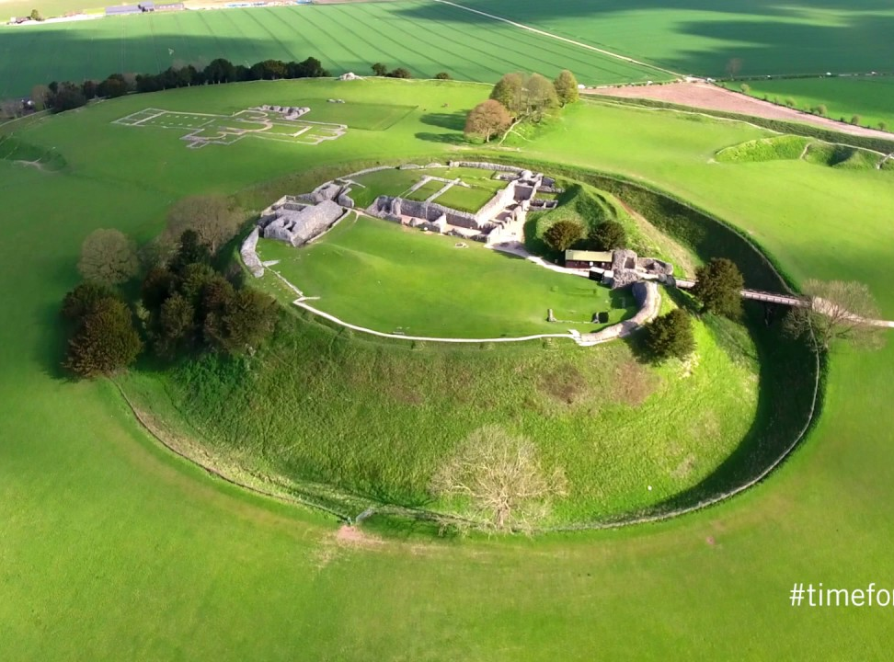  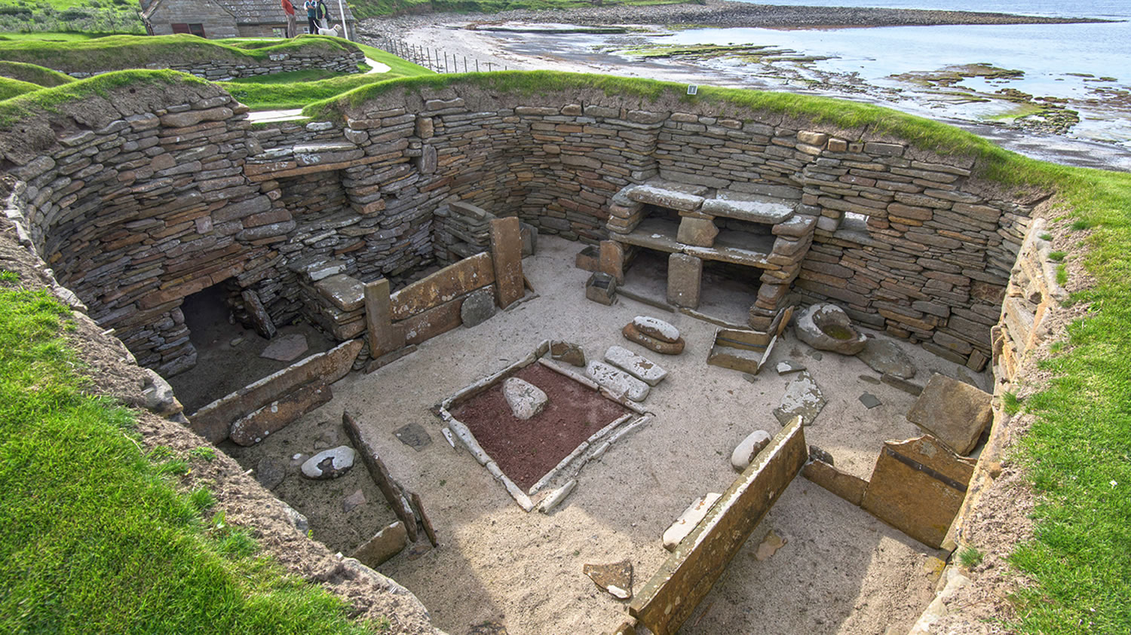  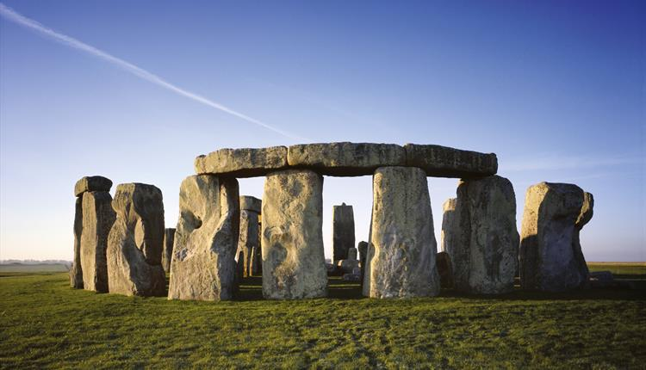
Time Line
