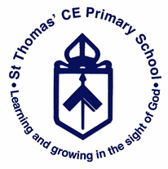
Y3 Knowledge Organiser
History- Ancient Civilisations
Question: What are the achievements of the earliest civilisations?

Key Facts | History Skills
- The 4 main civilisations we are going to compare are: Ancient Egypt, Ancient Sumer, Indus Valley and The Shang Dynasty.  - All had a written script such as hieroglyphics  - Ancient Egypt and Ancient Sumer have large structures such as pyramids and temples.  - All happened before Jesus was born.  - The clothing differs between civilisations. | Chronological understanding  - Use terms related to the period and begin to date events understand more complex terms e.g. BCE/AD  Historical Enquiry  - Use a range of sources to find out about a period.  - Observe small details – artefacts, pictures select and record information relevant to the study.  Historical Concepts  - Find out about everyday lives of people in time studied - Compare with our life today
Key Vocabulary | Pictures
Tick when you can explain the meaning to someone else.  Civilisation  Ancient  Mummifications  Ancient Egypt  Ancient Sumer  Indus Valley  Shang Dynasty  Sources  Artefacts | 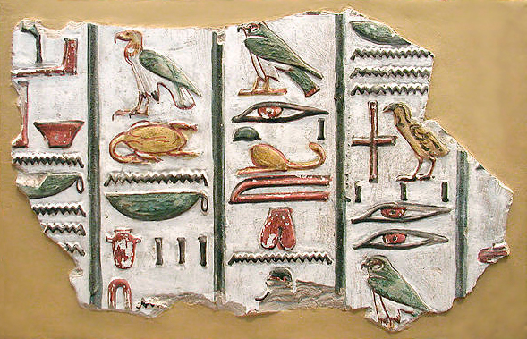  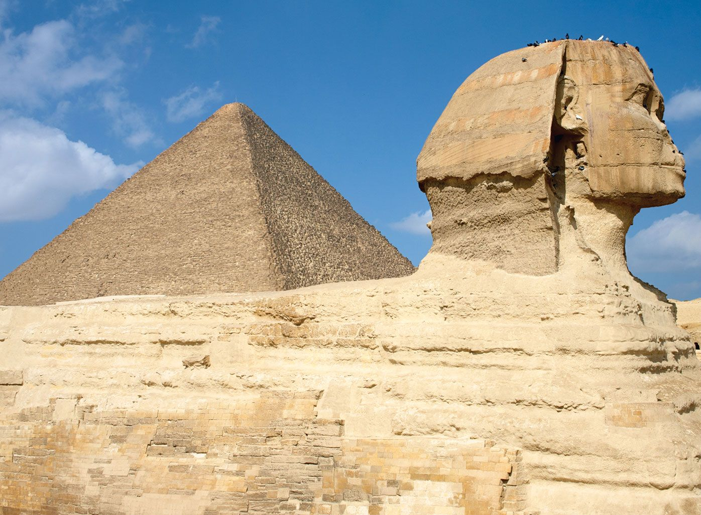  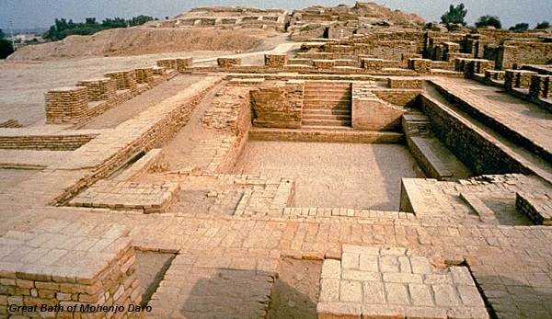  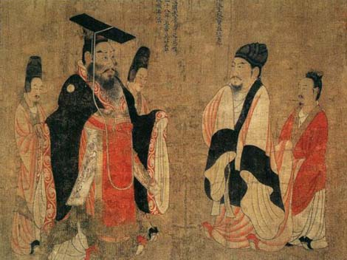
Time Line
