Y3 Knowledge Organiser | 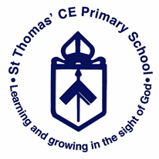
Geography– Extreme Earth

Key Facts |  | Geography Skills/Knowledge
- There are 7 continents in the World.  - There are 7 seas in the World.  - There are 195 countries in the World.  - There are 195 capital cities in the World. |  | - Describe and understand key aspects of: Brief introduction to Volcanoes and earthquakes linking to Science: rock types.  - Physical geography including Volcanoes and earthquakes, looking at plate tectonics and the ring of fire.  - Use maps, atlases, globes and digital/computer mapping (Google Earth) to locate countries and describe features studied.
Key Vocabulary & Glossary
Volcano – a mountain from which hot melted rock, gas, steam and ask from inside the Earth sometimes bursts.  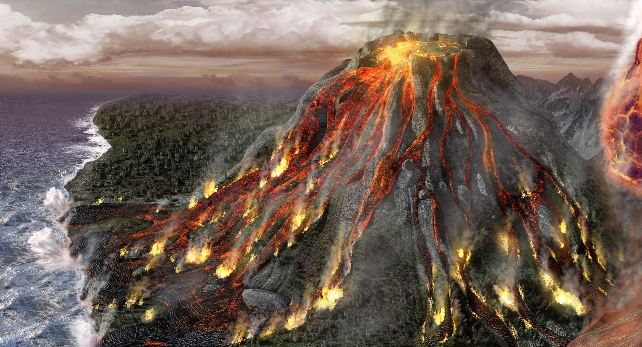 | Active Volcano – an active volcano has erupted recently or is expected to erupt soon.  Dormant Volcano – not active but is capable of erupting later on.  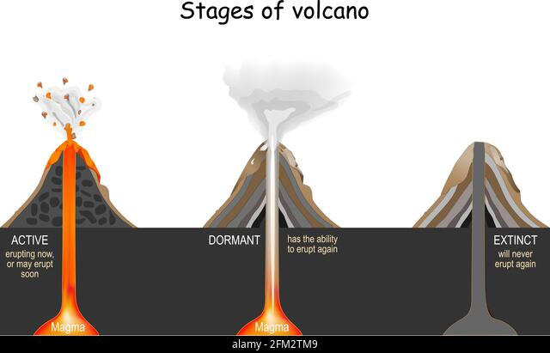 |  | Magma – molten rock that is formed in very hot conditions inside the Earth.  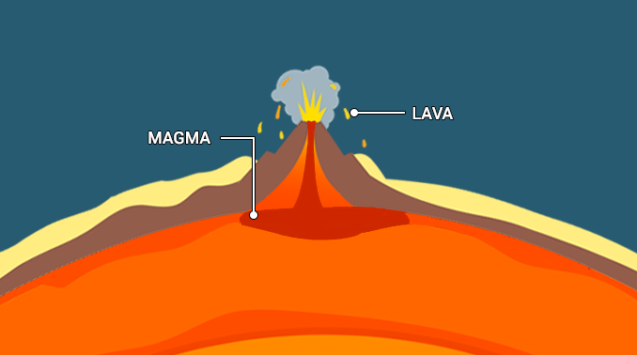
Crust – this is the outer layer of Earth.  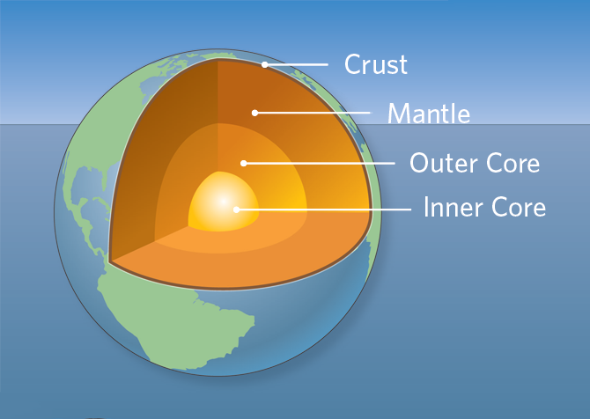 | Mantle – part of the Earth between the crust and the core.  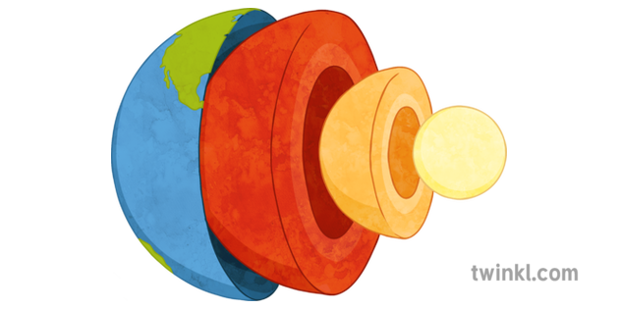 |  | Tectonic plates – any of the several segments of the Earth’s crust that move.  