Y3 Knowledge Organiser | 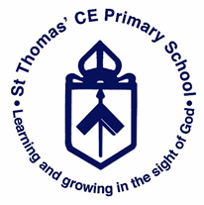
Geography– Fieldwork and map skills of local area

Key Facts |  | Geography Skills/Knowledge
- Compass points – N, NE, E, SE, S, SW, W, NW. |  | - Learn the eight points of a compass  - Learn basic ordnance survey symbols and a key  - Begin to use fieldwork to observe and record the human and physical features in the local area using sketch maps.  - Make a map of a short route with features
Key Vocabulary & Glossary
Compass - A piece of equipment that can help you navigate where to go.  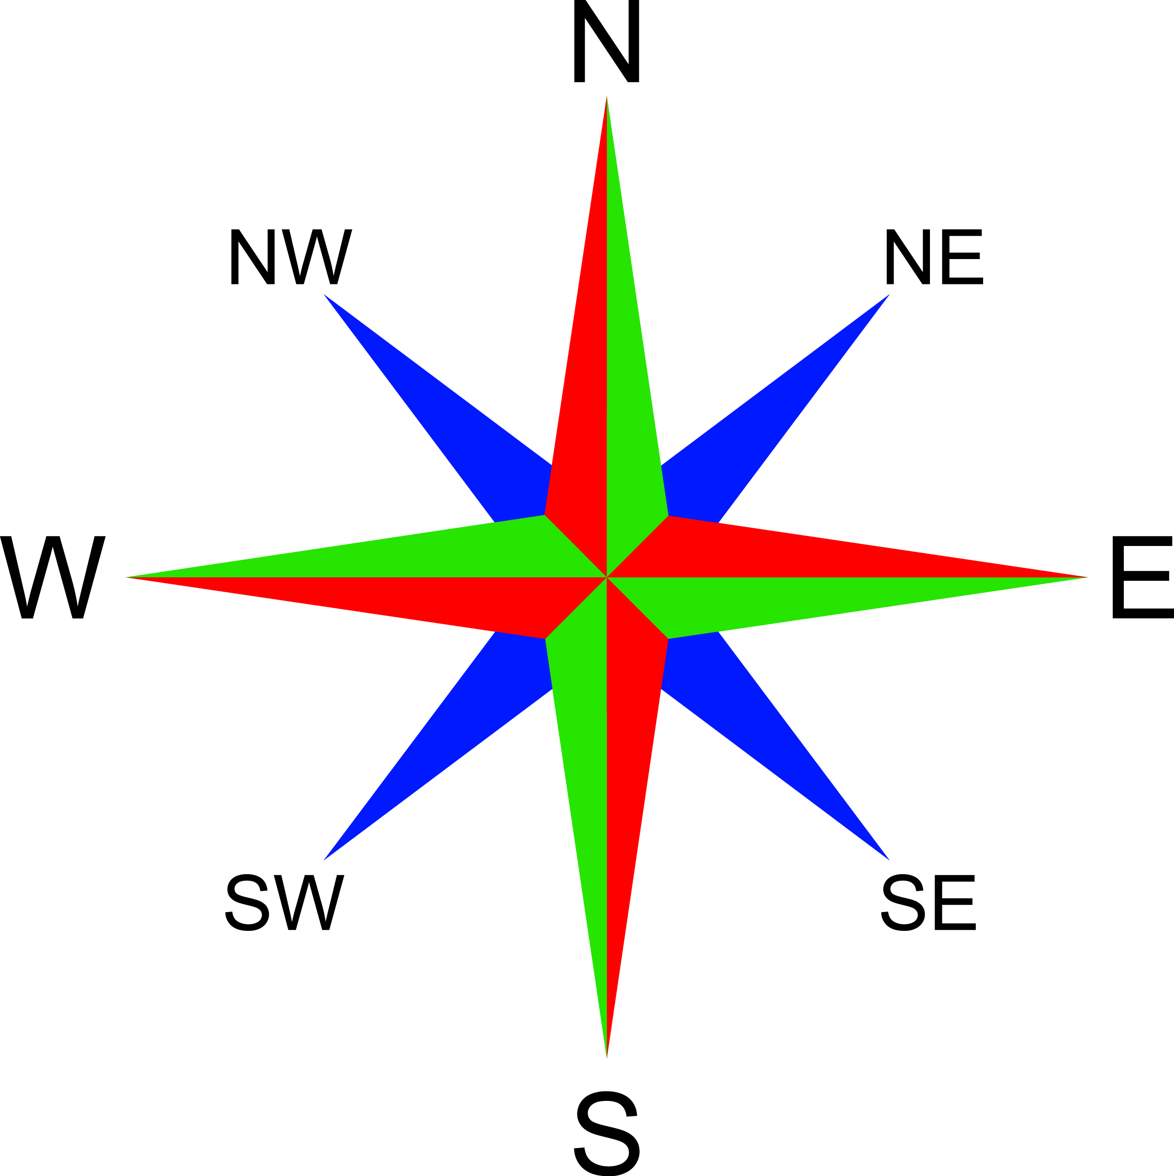 | Ordnance survey - The mapping agency for the UK  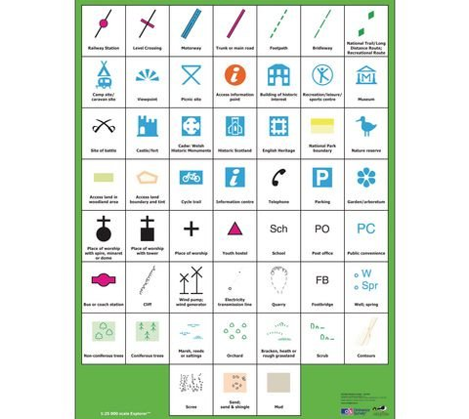 |  | Sketch map - An outline map showing only the main features  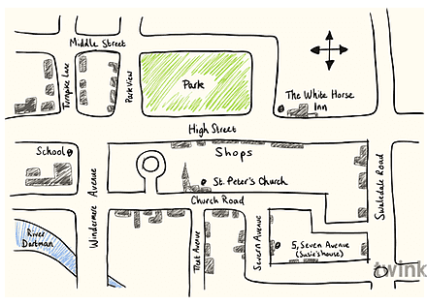
Key - A list of symbols that appear on a map and their meaning  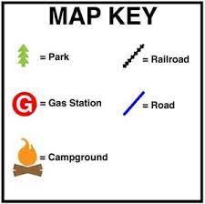 | Human features - Something that has been built by humans, e.g. houses, roads, landmarks.  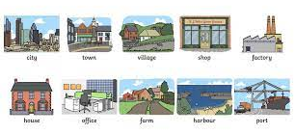 |  | Physical features - Natural features on the land e.g. mountains, rivers, volcanoes.
Fieldwork - Observing and collecting information and people and natural environments  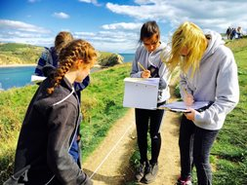 | Local Area - The area local to where you live |  | Heaton Moor - A town within Stockport (our local area around school)  