Modern Foreign Languages
Implementation
Please note that this document should be read in conjunction with the 3 core documents:
Topics/Vocab and skills’; ‘Grammar;’; ‘Phonics’
Summary
All pupils from Year 2 to Year 6 have access to a high-quality foreign languages curriculum using our own scheme of work and resources. This progressively develops pupils’ skills in French through regularly taught and well-planned weekly lessons. Pupils build on previous knowledge gradually as their foreign language lessons continue to recycle, revise and consolidate previously learnt language whilst building on all four language skills: listening, speaking, reading and writing.
At St Thomas’ CE our planning ensures that pupils gain systematic knowledge of the three pillars of language learning: phonics (sound and spelling systems), grammar and vocabulary, in order to build competency in French. We believe this to be essential because:
- we recognise the importance of exploring the patterns and sounds of language to develop accurate pronunciation and intonation
- we understand the necessity of building on the foundations of grammar so that pupils can apply increasingly complex and challenging grammatical rules
- we strive to develop pupils’ ability to understand new vocabulary and take advantage of opportunities for vocabulary retrieval practice so that new words stick in long-term memory.
Note our core curriculum documents:
- ‘Topics/Vocab and skills ’; ‘Grammar; ‘Phonics’
These show what each class in each year group will be taught and when it will be taught during the current academic year to ensure substantial progress and learning is achieved. Pupil learning and progression is assessed at regular intervals in line with school policy. Please note that the timings of units may change: the impact of Covid 19 means we must be flexible and address gaps in pupils’ learning where necessary. Staff continue to use formative assessment to ensure that children make progress in the core essentials as identified in our attached documentation.

FRENCH CURRICULUM OVERVIEW 2021-22: GRAMMAR KNOWLEDGE AND DEVELOPMENT
Grammar | YEAR 2 | YEAR 3 | YEAR 4 | YEAR 5 | YEAR 6
Gender of nouns - definite and indefinite articles | Exposure to le la les (parts of the body)  and un/une (classroom objects) | Focus on active use of definite articles in the singular and plural with masculine and feminine nouns eg j’ai un crayon, voici le crayon | Focus on active use of indefinite articles in singular eg j’ai un chien, une tortue | Accurate use of correct article with school subjects + understanding of the importance of this  Jouer au/à la / à l’/aux  Faire du/de la /de l’/des | Accurate gender and article use, singular and plural
Singular and plural forms of nouns | Exposure to plural :  un crayon, deux crayons (not written) | Form plural nouns | Use of plural nouns  Differentiate between countable and uncountable nouns when expressing opinions eg j’aime les bananes, j’aime le chocolat | Know how to use countable and uncountable nouns when talking about likes and dislikes:  j’aime le fromage  je n’aime pas les frites | Confident use of countable and uncountable nouns when talking about likes and dislikes
Adjectives (place and agreement) | Exposure to un crayon bleu | Learn adjectival positioning with colours: un crayon bleu | Use adjectives (position) with more confidence and start agreements  j’ai un chien marron et deux lapins blancs | Remember to match number and gender when describing self and other things  je suis intelligent(e)  Vénus est une planète chaude | Remember to match number and gender when describing self and other things  Ma soeur est intelligente
Conjugation of key verbs (and making verbs negative)  also imperatives  also je peux...(?)  also mention subject pronouns  opinion verbs inc je pense que | Exposure to j’ai les yeux bleus,  Le vieux McDonald a une ferme | s’appeler 1, 2, 3  avoir 1,2  être 3  voir 1,2  regarder 3  Use of tu in questions, je in statements/answers about self  Tu as un crayon?  Oui, j’ai un crayon Negative – je n’ai pas (de crayon)  Est-ce que je peux aller aux toilettes ? | Subject pronouns 1,2,3  s’appeler 1,2,3  avoir 1,2,3  être 3  aimer 1,2  adorer 1  manger 1,2  boire 1,2  negative ne…pas  expressions with avoir : avoir faim, avoir soif  Impersonal verbs in weather expressions :  il y a du soleil  il fait beau  Est-ce que je peux aller aux toilettes ? | Subject pronouns 1,2,3,4,5,6  s’appeler 1,2,3,6  avoir 1,2,3  être 1,2,3  aimer 1,2,3  détester 1  préférer1,2,3  manger 1,2  boire 1,2  porter 1,2,3  jouer 1,2,3  faire 1,2,3  negative ne…pas  Impersonal verbs in negative:  il n’y a pas de soleil  Est-ce que je peux aller aux toilettes ? | Subject pronouns 1,2,3,4,5,6  s’appeler 1,2,3,6  avoir 1,2,3,4,5,6  être 1,2,3  aimer 1,2  détester 1,2  Use of il y a : A Stockport il y a des magasins etc  mais il n’y a pas de château  Est-ce que je peux aller aux toilettes ?  infinitives :  on peut aller aux magasins etc
Connectives and qualifiers, adverbs of time, prepositions of place;  conjunctions, intensifiers, prepositions, adverbs | Use days of the week and months of the year | Use connectives – et , mais | Use adverbs of time – le lundi je joue au foot ; quand il fait beau je vais à l’école à pied (mostly receptive) | Use qualifiers: Jupiter est une très grande planète | Use relative clauses eg:  À Stockport il y a la Mersey qui est un fleuve  Preps of place : quand je vais à l’école je passe devant un parc  Près de chez moi il y a un parc
Possessive pronouns | Exposure to ton and mon (birthday) | Use ton and mon in context of birthdays | Use mon, ma and mes with family and pets, also ton ta, tes | Use mon, ma and mes with clothes (Promenons-nous dans les bois) | Use mon, ma and mes with family and pets; also ton, ta tes in questioning others about their family
Questions | Quel âge as-tu?  Quelle est la date do ton anniversaire? (receptive) | Tu as un crayon ? | Tu aimes les bananes ?  alternative  Aimes-tu les bananes ? | Tu aimes les maths ?  + alternative  Aimes-tu les maths ? | Tu aimes les maths ?  + alternative  Aimes-tu les maths ?
Opinions |  |  | j’aime les oranges  tu aimes les bananes ?  Je n’aime pas les bananes mais j’adore les carottes | More complex sentences : J’aime les maths parce que c’est facile

TOPICS/VOCABULARY AND SKILLS DEVELOPMENT 2021-22
 | Autumn 1 | Autumn 2 | Spring 1 | Spring 2 | Summer 1 | Summer 2
Year 2  TOPICS/ VOCAB | Bonjour!  Une conversation en français  Les couleurs  Greetings & simple personal information  -Colours | Les numéros à 10  En classe  Joyeux Noël  Numbers to 10  Saying your age  Classroom language and objects  Christmas activities | Des Fêtes en France  Les numéros 0 à 20  Birthdays  Chinese New Year  Mardi Gras/Carnival (Spring 2 2022)  Numbers 0 to 20 | Les parties du corps  ‘Grand Monstre Vert’  Parts of the body  Grand Monstre Vert (for World Book Day and to consolidate parts of the body)  Easter activities | Les animaux à la ferme  Farm animals  Plurals of animals and saying which you like | J’aime le sport!  Sports/sporting events
SKILLS | Appreciate stories, songs, poems and rhymes in the language  Engage in conversations | Appreciate stories, songs, poems and rhymes in the language  Listen attentively to spoken language and show understanding by joining in and responding  Cultural knowledge and understanding  Engage in conversations  Seek clarification and help orally | Understand and respond to spoken language  Cultural knowledge and understanding  Speak with increasing confidence | Appreciate stories, songs, poems and rhymes in the language  Describe people, orally | Appreciate stories, songs, poems and rhymes in the language  Listen attentively to spoken language and show understanding by joining in and responding  Describe things and actions orally | Ask and answer questions  Engage in conversations  Describe actions orally  Speak with increasing confidence  Cultural knowledge and understanding
Year 3  TOPICS/ VOCAB | Bonjour ! Ça va ?  Comment ça s’écrit ?  Greetings & saying your name  Saying how you feel  Saying/writing the date  Teaching phoneme/ grapheme correspondence | Les numéros 0 à 15  Quel âge as-tu ?  Joyeux Noël  Numbers to 15  Saying your age | De quelle couleur est-ce ?  Using c’est to say what colour something is; asking what colour | En classe  Dans ma trousse  School equipment  Describing pencil crayons | Les animaux domestiques  Pets, their names and ages | ‘Ours Brun’  Learning how to describe the colours of animals through a story
SKILLS | Appreciate stories, songs, poems and rhymes in the language  Engage in conversations  Read carefully and show understanding of words  Cultural knowledge and understanding | Appreciate stories, songs, poems and rhymes in the language  Understand and respond to spoken language from a variety of authentic sources  Ask and answer questions  Read carefully and show understanding of words  Write words from memory  Cultural knowledge and understanding | Describe things orally  Read carefully and show understanding of words  Write words from memory | Listen attentively to spoken language and show understanding by joining in and responding  Ask and answer questions  Seek clarification and help orally  Read carefully and show understanding of phrases  Write words from memory  Describe things in writing  Cultural knowledge and understanding | Listen attentively to spoken language and show understanding by joining in and responding  Ask and answer questions, improving the accuracy of their pronunciation and intonation  Express opinions and respond to those of others  Read carefully and show understanding of simple writing  Describe things in writing  Write phrases from memory | Appreciate stories, songs, poems and rhymes in the language  Present information orally to a range of audiences  Understand and respond to written language from a variety of authentic sources  Adapt phrases to create new sentences, to express ideas clearly  Present ideas and information in writing to a range of audiences
Year 4  TOPICS/ VOCAB | Moi et ma famille  Comment ça s’écrit ?  Revision: name, age, greetings  Talk about myself and family  Phoneme/ grapheme correspondence  French alphabet and alphabetical order; spell name in French | Comment utiliser le dictionnaire ?  Quelle est la date ?  Joyeux Noël  Months and birthdays  Days and dates  Numbers to 31  Dictionary work | Tu as faim ?  L’Italie et l’italien (language awareness/ CC link)  Opinions of plural foods | Tu as faim ? cont  Joyeuses Pâques  Opinions of singular foods | Quel temps fait-il?  Weather, compass points  and towns | La géographie de la France  Weather, compass points  and towns
SKILLS | Listen attentively to spoken language and show understanding by joining in and responding  Ask and answer questions  Engage in conversations  Read carefully and show understanding of words  Present ideas and information in writing to a range of audiences | Appreciate stories, songs, poems and rhymes in the language  Read carefully and show understanding of words  Write words from memory  Cultural knowledge and understanding | Ask and answer questions  Engage in conversations  Speak with increasing confidence  Read carefully and show understanding of phrases  Broaden vocabulary and develop ability to understand new words that are introduced into familiar written material, including through using a dictionary  Express opinions and respond to those of others  Adapt phrases to create new sentences, to express ideas clearly  Cultural knowledge and understanding | Appreciate stories, songs, poems and rhymes in the language  Speak with increasing confidence  Express opinions and respond to those of others  Read carefully and show understanding of simple writing  Adapt phrases to create new sentences, to express ideas clearly  Write phrases from memory  Cultural knowledge and understanding | Appreciate stories, songs, poems and rhymes in the language  Listen attentively to spoken language and show understanding by joining in and responding  Present ideas and information orally to a range of audiences, improving the accuracy of their pronunciation and intonation  Understand and respond to written language from a variety of authentic sources  Broaden vocabulary and develop ability to understand new words that are introduced into familiar written material, including through using a dictionary  Adapt phrases to create new sentences, to express ideas clearly in writing | Present ideas and information orally to a range of audiences  Read carefully and show understanding of simple writing  Write phrases from memory  Present ideas and information in writing to a range of audiences  Cultural knowledge and understanding
Year 5  TOPICS/ VOCAB | C’est la Rentrée!  Comment ça s’écrit?  Revision of personal information, opinions about food, phonics etc  Phoneme/ grapheme correspondence  Spell name using French alphabet  Using Duolingo for Schools | À l’école  Joyeux Noël  School subjects and opinions | Les Planètes  Describing the planets | Les descriptions  Joyeuses Pâques  Describing clothes using adjectives correctly (position and endings)  Personal description - hair, eyes, personality | Quelle heure est-il?  Les numéros à 60  Telling the time | J’aime les sports  Talking about sports you do and opinions of them
SKILLS | Appreciate stories, songs, poems and rhymes in the language  Engage in conversations  Read carefully and show understanding of phrases  Write words from memory  Cultural knowledge and understanding | Appreciate stories, songs, poems and rhymes in the language  Listen attentively to spoken language and show understanding by joining in and responding  Ask and answer questions, improving the accuracy of their pronunciation and intonation  Express opinions and respond to those of others  Read carefully and show understanding of simple writing  Write phrases from memory  Present ideas and information in writing to a range of audiences  Cultural knowledge and understanding | Present ideas and information orally to a range of audiences  Understand and respond to written language from a variety of authentic sources  Read carefully and show understanding of phrases  Adapt phrases to create new sentences, to express ideas clearly  Describe people, places, things and actions in writing  Write at varying length, for different purposes and audiences, using the variety of grammatical structures that they have learnt | Understand and respond to spoken language from a variety of authentic sources  Describe people, places, things and actions orally  Read carefully and show understanding of phrases  Write phrases from memory  Describe people, places, things and actions in writing, improving the accuracy of their pronunciation and intonation  Cultural knowledge and understanding  Develop an appreciation of a range of writing | Appreciate stories, songs, poems and rhymes in the language  Present ideas and information orally to a range of audiences  Ask and answer questions  Read carefully and show understanding of phrases  Write phrases from memory | Understand and respond to spoken language from a variety of authentic sources  Express opinions and respond to those of others  Speak with increasing confidence, fluency and spontaneity  Improving the accuracy of their pronunciation and intonation  Read carefully and show understanding of simple writing  Understand and respond to written language from a variety of authentic sources  Present ideas and information in writing to a range of audiences  Cultural knowledge and understanding
Year 6  TOPICS/ VOCAB | Tout sur moi  Revision of personal information, opinions, descriptions, phonics etc  phoneme/ grapheme correspondence  Using Duolingo for Schools | Comment ça s’écrit?  Joyeux Noël  Revision of French alphabet and DICTIONARY use  Letters to our friends in Toulouse | Ma Ville  Describing our town and saying what is there | Comment vas-tu à l’école ?  Saying what you can do in  our town  Transports and the verb to go | Les Pays francophones  Learning about France and other French-speaking countries | Révision  Preparation for KS3  including numbers to 60
SKILLS | Appreciate stories, songs, poems and rhymes in the language  Engage in conversations  Read carefully and show understanding of simple writing  Broaden vocabulary and develop ability to understand new words that are introduced into familiar written material, including through using a dictionary  Present ideas and information in writing to a range of audiences  Write at varying length, for different purposes and audiences, using the variety of grammatical structures that they have learnt  Develop an appreciation of a range of writing | Understand and respond to spoken language from a variety of authentic sources  Speak with increasing confidence, fluency and spontaneity  Read carefully and show understanding of phrases  Present ideas and information in writing to a range of audiences  Write at varying length, for different purposes and audiences  Broaden vocabulary and develop ability to understand new words that are introduced into familiar written material, including through using a dictionary  Cultural knowledge and understanding | Listen attentively to spoken language and show understanding by joining in and responding  Speak with increasing confidence, fluency and spontaneity  Describe people, places, things and actions orally  Understand and respond to written language from a variety of authentic sources  Write phrases from memory  Describe people, places, things and actions in writing  Cultural knowledge and understanding  Write at varying length, for different purposes and audiences, using the variety of grammatical structures that they have learnt  Develop an appreciation of a range of writing | Understand and respond to spoken language from a variety of authentic sources  Listen attentively to spoken language and show understanding by joining in and responding  Describe people, places, things and actions orally  Broaden vocabulary and develop ability to understand new words that are introduced into familiar written material, including through using a dictionary  Describe people, places, things and actions in writing  Adapt phrases to create new sentences, to express ideas clearly | Listen attentively to spoken language and show understanding by joining in and responding  Describe people, places, things and actions orally  Understand and respond to written language from a variety of authentic sources  Read carefully and show understanding of simple writing  Write at varying length, for different purposes and audiences  Present ideas and information in writing to a range of audiences  Cultural knowledge and understanding | Understand and respond to spoken language from a variety of authentic sources  Present ideas and information orally to a range of audiences  Speak with increasing confidence, fluency and spontaneity  Read carefully and show understanding of simple writing  Describe people, places, things and actions in writing  Present ideas and information in writing to a range of audiences  Write at varying length, for different purposes and audiences  Write at varying length, for different purposes and audiences, using the variety of grammatical structures that they have lear

FRENCH CURRICULUM OVERVIEW 2021-22: PHONICS KNOWLEDGE AND DEVELOPMENT

Listening/ Reading | Y2 | Y3 | Y4 | Y5 | Y6
Link the spelling, sound and meaning of words  Explore the patterns and sounds of language through songs and rhymes and link the spelling, sound and meaning of words  Develop accurate pronunciation and intonation so that others understand when they are reading aloud or using familiar words and phrases | Develop phonics knowledge  with exposure to some key French sounds especially:  j/ r/  an/en/  ch/  ien  silent t, silent s | Apply phonics knowledge, pronunciation, spelling prediction activities (e.g. gap-fills)  Overt teaching of key sounds with examples and actions  TERM 1  a-e-i-e-u (y)  on/ j / oi /ç/ an  silent s  TERM 2  ou/ au/ eu/ oi/i/  an/ -ge/o/ on/  silent s, silent t  oy/o/ au  TERM 3  ch/ in/ on/ en/ ou / au/ u  silent s  oi / qu/ ou/ un | Develop phonics knowledge and confidence through: rhymes and songs eg Léon le Caméléon, Il a les yeux rouges  Overt teaching of key sounds with examples and actions  TERM 1  Revision of Y3 sounds +  ère/ on/ a/ an/ on / ou/ in / ine  on/ ei/ qu / au  TERM 2 :  Constant revision +  oi / an /  TERM 3  Constant revision +  em/ y / ai  + silent letters | Anticipate with some accuracy the spelling of new words they hear, by applying their phonics knowledge  eg when seeing new vocab school subjects – attempt to pronounce using phonics knowledge  Overt teaching of key sounds with examples and actions  TERM 1  Revision of all sounds done so far+  é / è / ez / er  TERM 2  on/ eau/ è / un / ch  è/ ez / et / an/ in / en / eu  TERM 3  ui / eu/ tion/  + silent letters  + liaison | Anticipate with some accuracy the spelling of new words they hear, by applying their phonics knowledge  eg weather rhymes activity  Overt teaching of key sounds with examples and actions  TERM 1  Revision of all sounds done so far  TERM 2  ill / y /  en / ai /  TERM 3  ç/  + silent letters + liaison

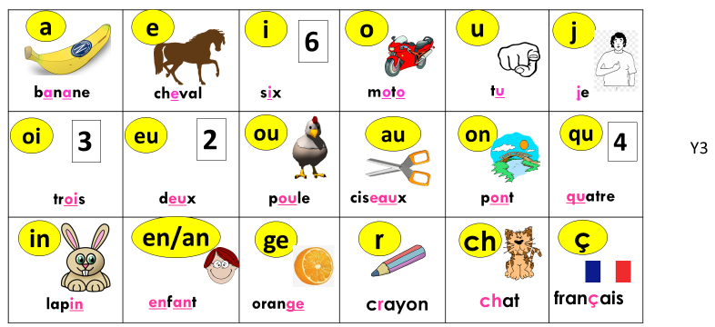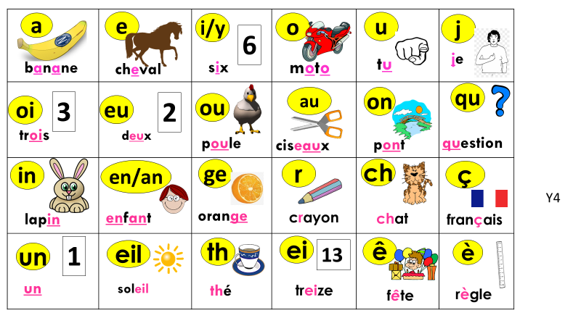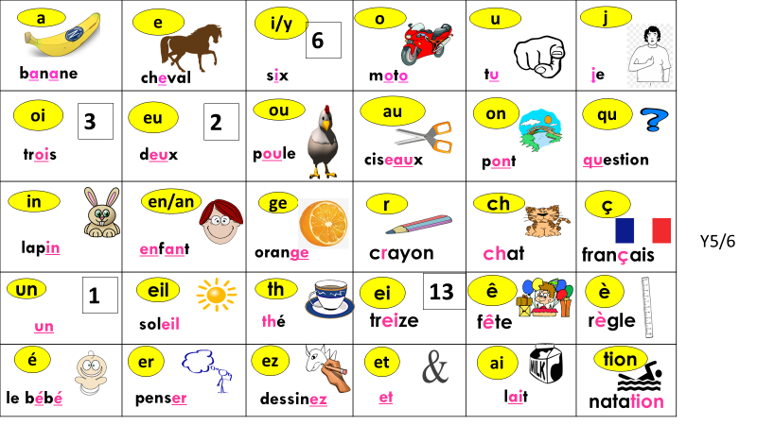APPENDIX

