Key Workers and children staying at home Home Learning
WB 20th July
 | Maths |  | English
Monday | Multiplication 1:  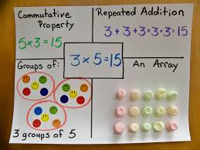  Show the children these methods of solving addition. Which do they understand? Can they explain how any of them work?  Discuss that multiplication is “lots of” e.g. 3 x 2 is 3 lots of 2.  We will focus on using arrays today.  Arrays.  Draw 8 dots as an array of 2 x 4  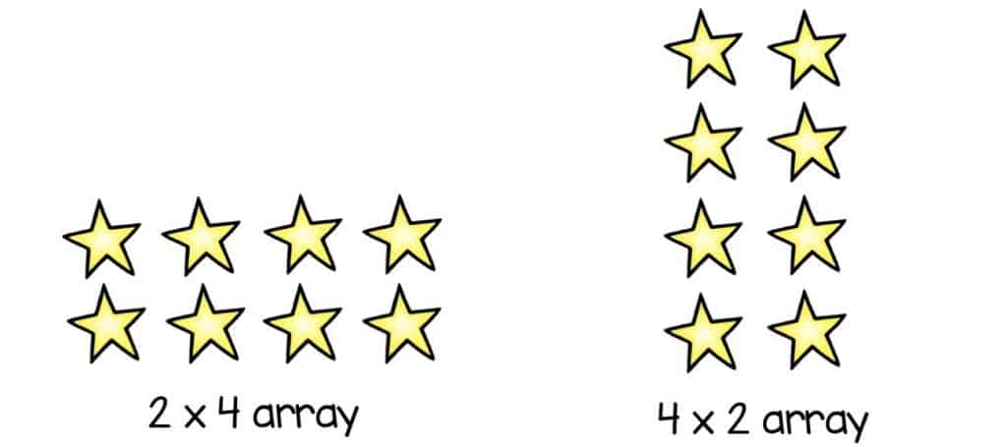  Ask children how many dots are there and how they worked it out. Explore how we can count the dots one by one, count in twos and count in 4s and the answer is always the same.  Now, how could we do this a little bit quicker? How many dots do I have across the top? As the child says the number, write it at the bottom of the array- 2  How many are in each column- going down? Start to write it as a multiplication x 4  How many do we have altogether? = 8 We can solve this by using our times tables, or by adding. See the examples below to discuss.  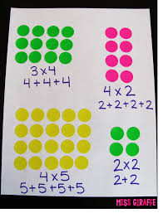  https://www.youtube.com/watch?v=lryvMT8cbeA  Complete the arrays challenge cards. |  | Recap – What has happened in the story so far? Continue reading.  What do you think the boy should do next?  Read the statement – The boy should stay on Earth and try to forget about the Martain on the Moon.  I want you to think about if you agree with it or not.  Pick a side. Children to have 5 mins on their side coming up with the reasons they agree/disagree. Children to share opinions – take the opposite stance of your child- can they convince you to change your mind?  Activity – Children to write their final opinion on their paper.  Encourage reasoning from your child–  I think this because…  Looking at the counter argument…  If he did this/did not do this…
Tuesday | Multiplication using number lines:  Use a number line.  If I have the calculation 3 x 2 = ?  How can I use a number line to solve it?  Explain that we need to do three jumps of two.  Can you explain why we need to do three jumps of two? What number do I land on? That is the answer.  Repeat for another few calculations.  2 x 5 = ?  How many jumps do I need to do? 2 jumps of 5. Why?  we could draw our own number lines too:  https://www.youtube.com/watch?v=LarPELLHgns  Complete the number line work on website. If you want a further challenge, have a go at the word problems. |  | Explain that today the children are going to re-write the story in their own words (could be done as a comic strip).  Begin to write the beginning of the story together. Purposely make mistakes – capital letters, not using phonics strategies. What do we need to check for? Is there anything we can improve on?  Recap on story language from previous learning.
Wednesday | Videos on Class Dojo
Thursday | We are going to look at how to use grouping to multiply.  Watch https://www.youtube.com/watch?v=LD4zp8ruvaI  Can you figure out what the multiplication number sentences are for these four pictures?  Can you draw groups to solve these number sentences?  2 x 4 =  3 x 7 =  6 x 4 =  7 x 8 = | Today you are going to think about things that you could tell your new teacher so that they can get to know you. Write down 3 interesting facts about yourself. Draw a picture to go with these facts (all three or just one).  Now write down 3 questions that you would like to ask your new teacher. Don’t forget to include capital letters and question marks.
Friday | Last day: Children to use iPads or laptops to play some maths games on the following websites.  - https://www.topmarks.co.uk/maths-games/5-7-years/counting  - http://www.maths-games.org/  - https://www.bbc.co.uk/bitesize/subjects/zjxhfg8 | Today is your last day in year 2. We would like you to choose something you really enjoy doing to celebrate completing year 2.  This could be dancing in your living room with the music on really loud, playing your favourite game or going to the park.  Have a lovely day! You deserve it.

