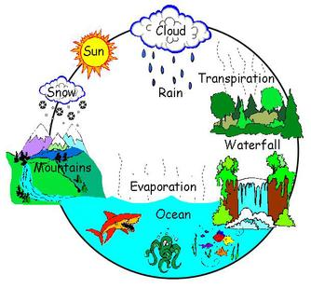

**Literacy:**

* Imaginary World stories
* Fables
* Non-Chronological reports – features of a river
* Explanation texts – what is the water cycle?
* Poetry

**Geography:**

* Why has Stockport developed in the way it has?
* Rivers
* The Water Cycle.

**Music:**

* Chiranga!

**ICT:**

**The past and present of Stockport**

**Year 4 are learning about…**

**Summer 2017**

**Art & Design Technology:**

* Photography – Neil Rowland
* Designing, making and evaluating a Stockport ‘Flag’- What represents Stockport?

**PE:**

* Outdoor- Football/ Basketball.
* Indoor - Gymnastics

**History:**

* Stockport in the past – What can we learn about it?

**Science:**

* States of Matter
* Living things and Habitats

**Mathematics:**

* Converting Units of Measure
* Perimeter/ Area
* Number and Place Value – Addition, Subtraction, Multiplication, Division, Fractions.
* Consolidation of topics

**PSHE:**

* Relationships
* Changes

**Religious Education:**

* God, David and the Psalms
* Jesus, the Son of God
* Proverbs