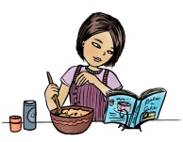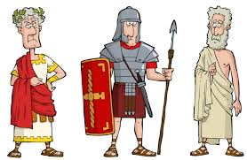

**Mathematics:**

* Roman Numerals
* Fractions and decimals
* Money
* Time
* Handling Data: Graphs

**Computing:**

* Coding

**PE:**

* Indoor – Gym/ Dance
* Outdoor – Hockey

**The Romans**

**Music:**

* Chiranga!

**Geography:**

* Italy – “Holidaying in Rome”

**Art & Design Technology:**

* Italian Artist: Leonardo Di Vinci, upscaling shell/ butterfly art work.
* Design and explore Roman/ Italian Cookery.

**History:**

* The Roman Empire and its impact on Britain.

**Science:**

* Animals including Humans: Digestion and Teeth.

**Religious Education:**

* Change the World
* Easter Prayer

**Literacy:**

* Narrative stories with Historical setting
* Diary of a Roman Soldier
* Fairy Stories
* Recount – The 3 Little Pigs

**PSHE:**

* Going for Goals
* Good to be me

**Year 4 are learning about…**

**Spring 2017**