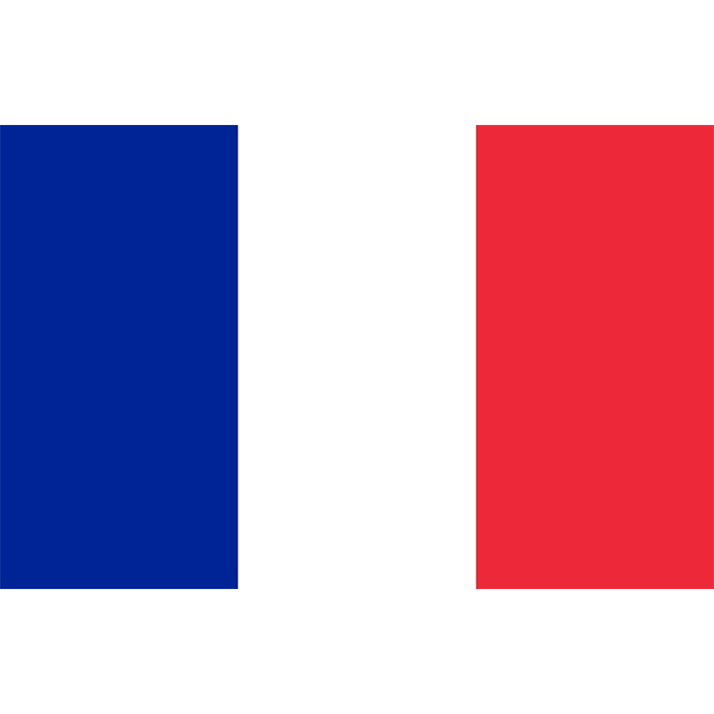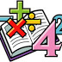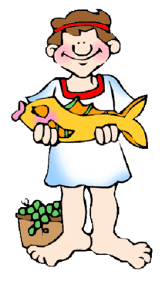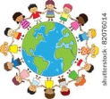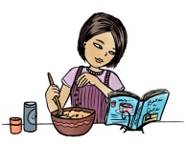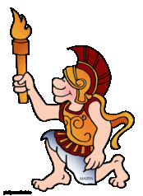

**French**

* Personal information/ Family
* Using the French dictionary
* Weather and Clothes

**Literacy:**

* Myths and Legends
* Greek Plays
* Syllabic Poetry
* Persuasive texts

**Mathematics:**

* Number and Place Value: Addition, Subtraction, Division and Multiplication.
* Understanding shape

**PSHE:**

* New Beginnings
* Say no to bullying

**Religious Education:**

* Christianity – The Bible and its importance to Christians
* Advent

**ICT:**

* E-Safety – keeping safe
* Digital Literacy – what does the internet do for us?

**PE:**

* Indoor – Gym/ Dance
* Swimming

**Art & Design Technology:**

* Designing, making and evaluating an Ancient Greek mask.
* Making our own musical instrument

**Music:**

* Chiranga – Mamma Mia!

**Geography:**

* Locational Knowledge – The Globe

**History:**

* Ancient Greece

**Science:**

* Sound
* Electricity – Could we live without it?

**The Ancient Greeks**

**Year 4 are learning about…**

**Autumn 2017**